Inference Training – a reading comprehension intervention for pupils in KS2 and KS3 who have age appropriate decoding skills but who are experiencing difficulty acquiring full meaning and enjoyment from their reading Sept 2013

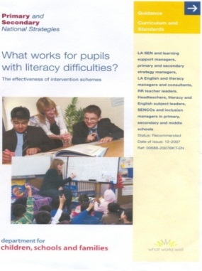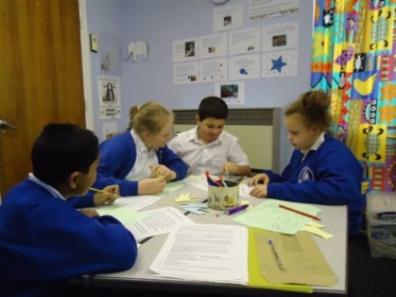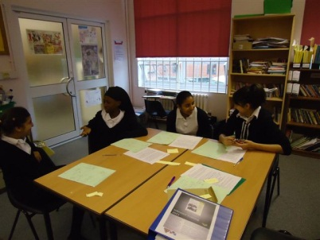

Inference training is a group intervention for pupils in KS2 and KS3 who decode adequately but fail to get full meaning and enjoyment from their reading. Evidence suggests one in ten pupils who decode satisfactorily, fail to get full meaning and enjoyment from reading. The techniques can also be used in KS2 and KS3 classrooms so that both classroom and group intervention approaches are aligned.

Inference training is adapted from the work of Nicola Yuill and Jane Oakhill “*Effects of Inference Awareness Training on Poor Reading Comprehension”* (1988). Subsequent work by Cain, Oakhill, Barnes and Bryant, 2001 and Cain and Oakhill 2011, shows the key role inference making plays in reading comprehension.

Inference training places importance on increasing adult sensitivity to the diverse problems pupils may experience in gaining full meaning and enjoyment from text. Studies reveal that pupils with weak comprehension skills read in different ways to effective readers.

Weak comprehenders

Effective readers



|  |  |
| --- | --- |
| * Focus on individual words/sentences * Attach most importance to decoding * Have a passive style of reading * Have lower expectations of text making sense and fewer comprehension monitoring strategies * Read fewer books and are less sensitive to story structure * Fail to activate background knowledge or visualise * Apply less integration and inference * Have a less efficient working memory | * Know that understanding is the goal of reading * Activate background knowledge and working memory * Integrate information/ideas and make inferences to get gist * Have high expectations of text making sense * Make predictions, ask own questions and watch out for “answers” * Can visualise when appropriate * Monitor meaning, notice breakdown and use breakdown strategies * Read frequently and enjoy reading |

A wide range of strategies

Inference training demonstrates a wide range of strategies through “instructional conversations” to help boost reading comprehension. Teachers can also use the strategies in guided reading or in English work in Secondary schools. (Specific training to use techniques with whole classes is offered from January 2014.) Through interactive discussions, the group:

* Activate and apply prior knowledge to their reading and use title cues to predict
* Identify key words and elaborate on them to enhance meaning, and develop vocabulary
* Generate their own questions and answer them
* Generate inferences and integrate meaning as they read to build a gist
* Summarise a short text extract using visualisation, quick pictures, picto-words and a 10 word or less headline
* Retell an extract to emphasise the gist

The inference training materials include 45 short text extracts for KS2 and KS3 pupils with support notes for adults. Many extracts are from recent award winning titles which have been carefully chosen to contain rich opportunities for pupils to discuss and enjoy. Further sections of the novels are also recommended so that pupils can apply their skills to whole texts. Schools will receive 20% discount when ordering extra copies of the books through Waterstones.

Most schools use inference training with groups of 4 pupils delivered by Teaching Assistants or teachers, usually two sessions of 40 minutes a week for eight to ten weeks.

Impact

Inference training featured in both the 2007 and 2013 editions of Professor Greg Brook’s study “*What Works for Pupils with Literacy Difficulties”.* Both editions identified inference training as an intervention that offers ***significant gains for pupils with weak comprehension skills.***  The latest pupil impact data from 326 pupils in KS2 and KS3 shows that during 14-20 inference training sessions, most pupils make 2 sub-levels progress in reading or an increase in reading comprehension of 12 months over 8-10 weeks.

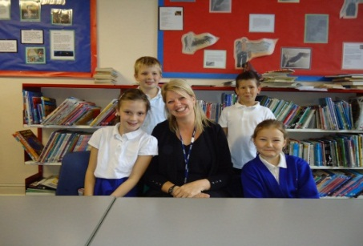

|  |
| --- |
| Marriott Primary school in Leicester use a range of effective evidenced based interventions including inference training. Anthony Roberts and Shirley Ledworth work with Y4-6 pupils and agree that …. *“it empowers the children and gives them more control and insight in their reading. They understand that there is much more to reading than decoding. For us adults, the training and teaching makes us understand the task of the reader much more. The pupils enjoy the sessions enormously.”*  Millie aged 10 reports that *.... “I never used to picture things in my head before and now I do.”* George aged 11 says “*It helps to show what you have to do when you read, and I like the talking we do in the group.”*  At Sir Jonathan North Secondary School, Y8 students enjoy the small group learning context and agree that *“the talking in a group helps us to read with more understanding and enjoyment. You share ideas about how to read so you understand clearly and learn from each other”.* |

Training for Schools

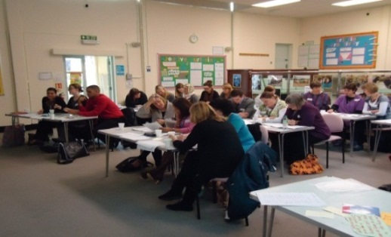

Around 45 **accredited inference trainers** in different parts of England offer *initial training* courses to schools using 3 flexible models

* All day 5 hour training
* Three twilight sessions ( one and a half hours each )
* A separate morning and afternoon session

*Follow up coaching/feedback sessions* *where an accredited trainer works alongside school staff and* pupils, *significantly improves pupil outcomes*. Additional twilight training sessions for class teachers to incorporate inference training approaches will be available from January 2014 *Teaching Assistants who deliver this intervention will particularly benefit from follow up coaching sessions*. The course components of *initial training* are:

* Key characteristics of reading comprehension
* The 13 main barriers to reading comprehension
* Sample pupil profiles which highlight a range of strengths and weaknesses in reading comprehension
* How to use short extracts of texts and 10 minute conversations with pupils to understand where their difficulties may lie
* How to deliver a 40 minute inference training session to pupils
* Participants have a go at an inference training session “as pupils”, led by volunteers
* How to provide on-going professional support to practitioners who deliver inference training to pupils
* Impact data and effectiveness/how to evaluate outcomes

The costs of the one day/5 hour initial training for a group of up to 24 teachers /Teaching Assistants are trainer costs plus Inference Training folders at a cost of £26 each, plus VAT and postage, (pp for 3 folders £9.04 /pp for 10 folders £14.17/ pp for 20 folders £26.22).The charge accredited trainers make varies from trainer to trainer. **Only schools who receive accredited training are provided with folders**.(A DVD with 2 inference lessons is also available)

Although the intervention is aimed at KS2/3 staff, the training sections on the characteristics of reading comprehension and barriers are extremely relevant for Foundation Stage and KS1 staff, since listening comprehension and reading comprehension are closely related.

Inference Training was adapted from the work of Yuill and Oakhill by Tony Whatmuff, with acknowledgement and thanks to the following colleagues in Leicester city for their valuable ideas and input.

Emma Kehoe ASD Specialist

Jo Puttick Primary Consultant

Harbans Khahra E2L specialist

Ian Todd Secondary Consultant

Julie McLay Speech and Language Practitioner

A special thanks to Jane Oakhill at Sussex University who has given advice and support in developing the 2013 edition of inference training and acknowledgement to Kate Cain’s book-Reading Development and Difficulties

[tony.whatmuff@leicester.gov.uk](mailto:tony.whatmuff@leicester.gov.uk)

**Contact details for accredited trainers is attached:**

|  |
| --- |
| *Addition details :* |
| **Key Information about Inference Training**   * For KS2/3 pupils who decode adequately but experience comprehension difficulties * It can be used as a group intervention techniques and adapted for use in classrooms (in guided reading or KS3 classrooms)Additional training is available from January 2014 * If used as a group intervention, 4 pupils work with an adult (trained TA or Teacher) for 40 minutes a session * Groups that have two sessions a week for 8-10 weeks make an average of 12 months progress in comprehension age (2/3 sub levels) * To measure progress of pupils in the group, we recommend using the Hodder Group Reading Test. This takes 20 minutes but can be given to all four pupils at once. * WE RECOMMEND follow up training. The trainer can work alongside the TAs for 2-3 inference lessons with all teachers so that class and intervention approaches are aligned. * Initial training is delivered by accredited inference trainers over:   + 3 twilights (1 ½ hours each)   + 1 whole day   + a separate morning and afternoon session (2 afternoons are not sufficient) * The Inference Manual/DVD is only available to schools that access the training. | |

<http://www.flickr.com/photos/paulsavala/813970624/sizes/z/in/photostream/>

<http://www.flickr.com/photos/39891373@N07/3665462673/sizes/l/in/photostream/>

|  |  |  |  |  |  |
| --- | --- | --- | --- | --- | --- |
| **Name** | **LA or self employed** | **Area able to train in** | **Contact e mail** | **KS2** | **KS3** |
| Angela Wilkins-Springs | LA | Buckinghamshire | awsprings@learningtrust.net | Y | Y |
| Liz Campbell |  | North London | liz.campbell-mm@mottmac.com |  |  |
| Anne Davis | School based | North/North East London | anne.davis@thorpehall.waltham.sch.uk | Y | Y |
| Rani Saini | LA | Ealing and West London | rsaini@ealing.gov.uk | Y | Y |
| Sue Shallcross | LA / Self Emp | Haringey Enfield Barnet | susan.shallcross@gmail.com | Y | Y |
| Karen Akroyd | LA | London Borough Merton | karen.akroyd@merton.gov.uk | Y | Y |
| Katherine Golden |  | London Borough of Merton | katherine.golden@merton.co.uk |  |  |
| Sue Jamal |  | London Borough of Merton | sue.jamal@merton.gov.uk |  |  |
| Viv Pratt |  | London Borough of Merton | viv.pratt@merton.gov.uk |  |  |
| Nafisa Shehu |  | London Borough of Merton | nafisa.shehu@merton.gov.uk |  |  |
| Sally Wilmot |  | London Borough of Merton | sally.wilmot@merton.gov.uk |  |  |
| Eileen Pike | Self Emp | Greenwich/Lewisham/Bexley | epike.mail@gmail.com | Y | Y |
| Rosina Junco | School based | Newham | rosinajunco@hotmail.com | Y | Y |
| Caroline MacGregor | LA | Essex Suffolk Thurrock Southend Herts | caroline.macgregor2@essex.gov.uk | Y | Y |
| Kathy Ewers |  | Essex Suffolk Thurrock Southend Herts | kathy.ewers@essex.gov.uk | Y | Y |
| Christine Cork | Self Emp | S E England, Kent (S E & Maidstone, Medway) | target.literacy@btinternet.com | Y | Y |
| Jennifer Harrison | Self Emp | South East / East Sussex | jennifer@readingworks.org.uk |  |  |
| Rebecca Shore | LA | Portsmouth Hampshire | rebecca.shore@portsmouthcc.gov.uk | Y | Y |
| Isabel Montgomery |  | Hampshire | isabel.montgomery@hants.gov.uk |  |  |
| Diane French | LA | Dorset and Hampshire West | d.e.french@dorsetcc.gov.uk |  |  |
| Jan Armstrong | LA | Bristol | jan.armstrong@bristol.gov.uk |  |  |
| Karen Stanley | LA | Cambridgeshire | karen.stanley@cambridgeshire.gov.uk | Y | N |
| Paula Burrell | LA | Nottinghamshire | paula.burrell@nottscc.gov.uk |  |  |
| Tony Whatmuff | LA | Leicester, East Midlands | tony.whatmuff@leicester.gov.uk | Y | Y |
| Joyce Bowley | LA | Warwickshire | joycebowley@warwickshire.gov.uk | Y | Y |
| Kalvinder Bains | School based | Birmingham | kalvinderb@hotmail.co.uk  k.bains@benson.bham.sch.uk | Y | Y |
| Alex Grady | School based | Staffordshire | agrady@fountains.staffs.sch.uk |  |  |
| Tara Chappell |  | Sheffield | ecar@acreshill.sheffield.sch.uk |  |  |
| Megan Dixon | Self Emp | Cheshire NW Shropshire | megan@damsoneducation.co.uk | Y | Y |
| Lindsey Howard |  | Cheshire | lindsay.howard@cheshirewestandchester.gov.uk |  |  |
| Karen Jacob | LA | Wirral Merseyside and W Wales | jacobk@fender.wirral.sch.uk | Y | Y |
| Gillian Crompton |  | Blackburn | g.crompton@blackburn.gov.uk |  |  |
| Leah Freeman |  | Oldham, Rochdale, Bury, Salford, Bolton | leah.freeman@oasislimeside.org |  |  |
| Jan Owens | Self Emp | Greater Manchester & North West | jan.ey2p@gmail.com |  |  |
| Angela Fisher | One education | Greater Manchester, Warrington, North Chesire, Calderdale & Bradford | angela.fisher@oneeducation.co.uk |  |  |
| Shirley Johnson | One education | shirley.johnson@oneeducation.co.uk |  |  |
| Fiona Botterill |  | Manchester, Trafford, Salford | fionabotterill@gmail.com | Y | Y |
| Dee Shenton |  | Tameside/Stockport/Wigan and Derbyshire | dee.shenton@pinfold.tameside.sch.uk |  |  |
| Julia Fletcher | One education | North West England | julesfletcher@btinternet.com | Y | Y |
| Allison Potter | LA | Tees Valley Sunderland | allison_potter@middlesbrough.gov.uk | Y | Y |